 | Sanjivani Rural Education Society's  SANJIVANI COLLEGE OF ENGINEERING  (An Autonomous Institution)  Kopargaon – 423 603, Maharashtra. | ACAD-F-15 K
Academic Year:  2026-27 | CIA ACTIVITY REPORT | Revision : 00
Department : | Computer Engineering | Date of Preparation
Course Code & Name: | PCCO201 : Discrete Mathematics | Year/Sem: S.Y B. Tech/ 3rd
Activity Title: Sum of Squares of First n Natural Numbers Using Mathematical Induction
Submitted by:
Group Id- ______________
Roll No | PRN No | Name of the Student | Signature
66 | 0125UCSM1066 | Kayastha Durgesh Manoj
67 | 0125UCSM1067 | Zalte Prem Dattatray
68 | 0125UCSM1068 | Unde Pranav Suresh
69 | 0125UCSF1069 | Harde Vaidehi Suklal
Dr. S. N Gunjal
Course Incharge

Abstract
Abstract—
Mathematical induction is one of the most fundamental proof techniques in discrete mathematics and computer science. It allows a statement that depends on a natural number to be established for infinitely many values by verifying only two things: a basis step and an inductive step. This report applies the principle of mathematical induction (PMI) to prove that the sum of the squares of the first n natural numbers is S(n) = n(n+1)(2n+1)/6 for every positive integer n. The proof is developed formally and is supported by three independent derivations (telescoping, combinatorial and geometric intuition) and by a discussion of the historical and theoretical background of induction.
The result is then studied from an algorithmic point of view. Three C++ programs are designed and implemented: (i) a constant-time evaluation of the closed-form formula, (ii) an iterative loop that accumulates the squares one by one, and (iii) a recursive function S(n) = S(n−1) + n² whose structure mirrors the inductive proof itself. The three implementations were tested for every value of n from 0 to 2000 with no mismatch, and benchmarked for n up to 100 000. The measurements confirm the expected complexities of O(1) for the formula and O(n) for both loop and recursion, with recursion also requiring O(n) stack space. Overflow limits of 64-bit arithmetic are analysed, and solved problems and applications in algorithm analysis, numerical integration, statistics and figurate numbers are presented.
Index Terms—Discrete mathematics, mathematical induction, sum of squares, recursion, algorithm analysis, C++.

Index
Abstract 2
Chapter 1 Introduction 4
1.1 Background 4
1.2 Problem Statement 4
1.3 Objectives 4
1.4 Scope and Limitations 4
1.5 Methodology 5
1.6 Organization of the Report 5
Chapter 2 Literature Survey 6
2.1 Natural Numbers and the Well-Ordering Principle 6
2.2 The Principle of Mathematical Induction 6
2.3 Strong and Structural Induction 7
2.4 Summation Notation and Recurrences 7
2.5 Historical Development 7
2.6 Known Results on Power Sums 7
2.7 Alternative Proofs of the Formula 8
2.8 Induction and Recursion 9
2.9 Applications 9
Chapter 3 System Design 11
3.1 Overall Design 11
3.2 Theorem and Proof by Induction 11
3.3 Algorithm 1: Formula Method 12
3.4 Algorithm 2: Iterative Method 12
3.5 Algorithm 3: Recursive Method 12
3.6 Complexity Comparison 13
3.7 Data Type and Overflow Analysis 13
3.8 Test Plan 13
Chapter 4 Implementation Details 14
4.1 Development Environment 14
4.2 Main Program 14
4.3 Explanation of the Code 15
4.4 Benchmark Program 15
4.5 Implementation Notes 16
Chapter 5 Result Screenshots and Analysis 17
5.1 Program Output 17
5.2 Growth of the Sum 18
5.3 Performance Comparison 18
5.4 Analysis of Results 19
5.5 Problem Solutions 20
5.6 A Cautionary Example 20
Chapter 6 Conclusion 21
6.1 Conclusion 21
6.2 Future Scope 21
References 22
Annexure 1: GitHub Upload Screenshot 23
Annexure 2: Presentation Geo-Tag Photo 24
Annexure 3: Certificate of Online Course 25

Chapter 1 Introduction

1.1 Background
Discrete mathematics studies structures that are countable and separate rather than continuous: integers, graphs, logical statements, sets and sequences. Among its tools, mathematical induction occupies a central place because a great many statements in mathematics and computing are of the form “for every natural number n, property P(n) holds”. Examples range from closed-form expressions for sums, to inequalities, divisibility results, the correctness of recursive programs, and the running time of algorithms [1], [2].
A classic illustration is the sum of the squares of the first n natural numbers. Writing S(n) = 1² + 2² + … + n², one observes S(1) = 1, S(2) = 5, S(3) = 14, S(4) = 30 and S(5) = 55. These numbers are not arbitrary: they follow the compact expression n(n+1)(2n+1)/6. Discovering such a formula is a matter of pattern recognition or of algebraic technique, but proving that it holds for all n requires an argument that covers infinitely many cases at once. Mathematical induction provides exactly this argument.
Because the formula is simple, and because the sum can also be computed by a loop or by a recursive function, it is an ideal meeting point of mathematics and programming. The recurrence S(n) = S(n−1) + n² is at the same time the inductive step of the proof and the recursive step of the program. This project exploits that connection.

1.2 Problem Statement
The problem addressed in this project is stated as follows: to prove, using mathematical induction, that the sum of the squares of the first n natural numbers is given by the formula n(n+1)(2n+1)/6, and to implement the calculation of this sum in C++ using three methods—the formula method, the iterative method and the recursive method (which demonstrates induction).

1.3 Objectives
- To study the well-ordering principle, the principle of mathematical induction and their role in proving statements about natural numbers.
- To give a complete and rigorous inductive proof of the sum-of-squares formula, and to compare it with alternative proofs.
- To design three algorithms—closed form, iteration and recursion—for computing the sum, and to analyse their time and space complexity.
- To implement, test and benchmark the algorithms in C++, and to verify that they agree for all tested inputs.
- To identify applications of the result and to solve representative problems based on the technique.

1.4 Scope and Limitations
The report covers the theory of weak induction with a detailed treatment of the sum of squares, together with closely related sums. The programs use the built-in 64-bit unsigned integer type (unsigned long long); arbitrary-precision arithmetic is outside the scope, so the valid range of n is limited as analysed in Section 3.7. Timing results depend on the machine, compiler and optimisation level, and are meant to show trends rather than absolute values.

1.5 Methodology
The work followed four stages. First, the relevant theory was collected from standard textbooks [1]–[3], [6]–[8]. Second, the theorem was proved by induction and cross-checked by three other proofs. Third, the algorithms were designed, their correctness argued and their complexity derived. Fourth, the algorithms were coded in C++, compiled with the GNU compiler, tested exhaustively for small inputs and benchmarked for large ones. Every group member contributed to one or more of these stages, and the results were consolidated in this report and in the accompanying presentation.

1.6 Organization of the Report
Chapter 2 presents the literature survey, covering relevant theory, history, alternative proofs and applications. Chapter 3 describes the system design: the formal proof, the three algorithms, complexity, data-type limits and the test plan. Chapter 4 documents the C++ implementation. Chapter 5 presents result screenshots, performance analysis and solved problems. Chapter 6 concludes the report and suggests future work. References and annexures follow.

Chapter 2 Literature Survey

2.1 Natural Numbers and the Well-Ordering Principle
The set of natural numbers ℕ = {1, 2, 3, …} is built on a simple idea: there is a first element, and every element has a unique successor. Peano’s axioms formalise this, and the last of them is precisely the induction axiom: any subset of ℕ that contains 1 and contains the successor of each of its members is all of ℕ [1], [7]. An equivalent statement is the well-ordering principle: every non-empty subset of the natural numbers has a least element.
The two principles are logically equivalent. To see that well-ordering implies induction, suppose P(1) is true and P(k) → P(k+1) for all k, but P(n) fails for some n. Then the set of counter-examples is non-empty and, by well-ordering, has a least element m. Since P(1) is true, m > 1, so m−1 is a natural number for which P holds; but then P(m) holds by the inductive step, a contradiction. This short argument is the theoretical justification for every induction proof in this report.

2.2 The Principle of Mathematical Induction
Let P(n) be a statement about the natural number n. The principle of mathematical induction (PMI) states:
[ P(1) ∧ ∀k ( P(k) → P(k+1) ) ] → ∀n P(n).
A proof by induction therefore has three components:
- Basis step. Verify that P(1) (or P(n₀) for the first relevant value n₀) is true.
- Inductive hypothesis. Assume that P(k) is true for an arbitrary but fixed k ≥ 1.
- Inductive step. Using the hypothesis, prove that P(k+1) is also true. Conclude that P(n) holds for all n ≥ 1.
The standard metaphor is a line of dominoes. The basis step topples the first domino; the inductive step guarantees that whenever one domino falls, the next also falls. Together they ensure that every domino falls. Neither component alone is sufficient (Section 5.6 gives an example of a false “proof” whose inductive step is valid but whose basis fails).
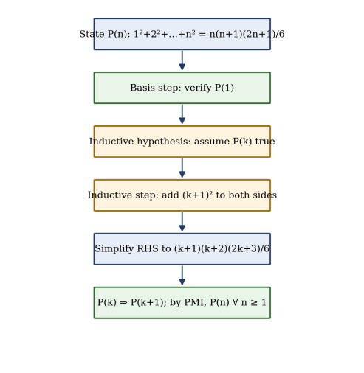
Fig. 1. Flow of a proof by mathematical induction for the sum-of-squares formula.

2.3 Strong and Structural Induction
In strong induction the inductive hypothesis is strengthened: to prove P(k+1) one may assume P(1), P(2), …, P(k) all hold. Strong induction is logically equivalent to weak induction but is more convenient when a statement about n depends on several smaller cases, as in the proof that every integer greater than 1 has a prime factorisation. Structural induction extends the idea to recursively defined objects such as lists, trees and well-formed formulas: one proves the property for the base objects and shows that it is preserved by every constructor [1], [3]. For the sum of squares, ordinary (weak) induction is sufficient and most natural, because S(k+1) depends only on S(k).

2.4 Summation Notation and Recurrences
The sum of the squares of the first n natural numbers is written with the summation symbol as
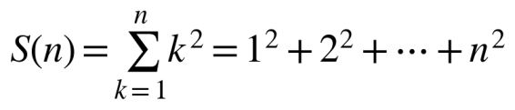 (1)
Summation is linear: Σ(a·xₖ + b·yₖ) = aΣxₖ + bΣyₖ. Splitting off the last term of the sum gives the recurrence relation
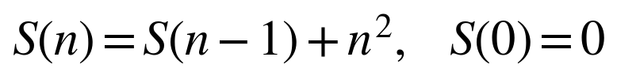 (2)
Equation (2) is a recursive definition: it defines S(n) in terms of S(n−1), with S(0) = 0 as the base case. This is the bridge between induction and recursion that is exploited in the recursive C++ method. A closed form is a formula that gives S(n) directly without reference to smaller values; finding it is the subject of Sections 2.6 and 2.7, and verifying it is the purpose of the proof in Section 3.2.

2.5 Historical Development
Sums of powers of integers are among the oldest problems in mathematics. Archimedes, in his work On Spirals, obtained the sum of the squares of the first n integers by a geometric argument in order to find the area bounded by a spiral [10]. Explicit closed forms for higher powers were published by Johann Faulhaber in 1631 and were later placed on a general footing by Jakob Bernoulli, whose numbers appear in the general formula for Σ k^p published posthumously in Ars Conjectandi (1713) [11].
The technique of induction itself emerged gradually. Francesco Maurolico used an argument of this type in his Arithmeticorum libri duo (1575) to prove that the sum of the first n odd numbers is n². Blaise Pascal stated the method explicitly in his treatise on the arithmetical triangle, written in 1654, using it to establish properties of binomial coefficients. The name “mathematical induction” and its formalisation through Peano’s axioms came in the nineteenth century [1], [10]. Today the method is a compulsory part of the discrete mathematics curriculum and of the theory of algorithms [3], [6].

2.6 Known Results on Power Sums
Table I collects the closed forms for the first four power sums. Each of them can be proved by induction; in general Σ k^p is a polynomial of degree p+1 in n [2].
TABLE I
CLOSED FORMS FOR SUMS OF POWERS OF THE FIRST N NATURAL NUMBERS
Sum | Closed form | Value for n = 10
Σ k | n(n+1)/2 | 55
Σ k² | n(n+1)(2n+1)/6 | 385
Σ k³ | [n(n+1)/2]² | 3025
Σ k⁴ | n(n+1)(2n+1)(3n²+3n−1)/30 | 25333

The sum of squares also has the following properties, all of which can be read directly from the formula: (a) S(n) is always an integer, because the product n(n+1)(2n+1) is divisible by 2 (two consecutive integers) and by 3 (among n, n+1 and 2n+1 one is a multiple of three); (b) S(n) = n³/3 + n²/2 + n/6, so S(n) grows like n³/3; and (c) the numbers S(1), S(2), … = 1, 5, 14, 30, 55, 91, 140, … are the square pyramidal numbers, the number of stacked spheres in a pyramid with a square base of side n [10]. Fig. 2 shows the squares involved for n = 5.
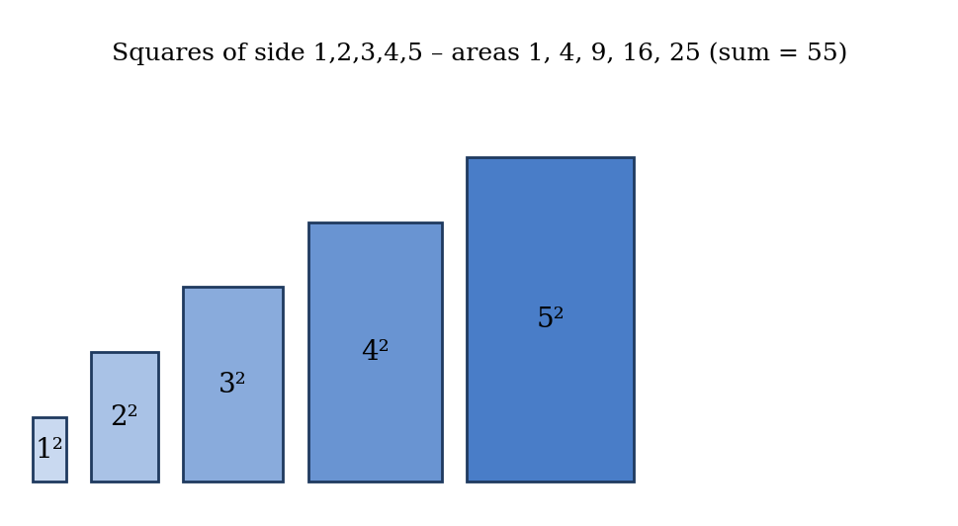
Fig. 2. Squares of side 1 to 5; their areas 1 + 4 + 9 + 16 + 25 add to S(5) = 55.

2.7 Alternative Proofs of the Formula
Although this report concentrates on induction, it is instructive to see that the same formula can be reached by other routes. These derivations also serve as independent checks of the result.

2.7.1 Telescoping Method
Start from the binomial identity for consecutive cubes:
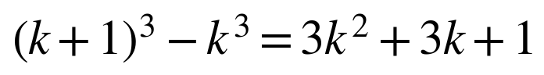 (3)
Summing Equation (3) from k = 1 to n, the left-hand side telescopes to (n+1)³ − 1, while the right-hand side becomes 3S(n) + 3·n(n+1)/2 + n. Hence 3S(n) = (n+1)³ − 1 − 3n(n+1)/2 − n, which simplifies to S(n) = n(n+1)(2n+1)/6. Unlike induction, this method derives the formula instead of verifying a known one.

2.7.2 Combinatorial Method
Since k² = 2·C(k,2) + k, summing over k and using the hockey-stick identity Σ C(k,2) = C(n+1,3) gives
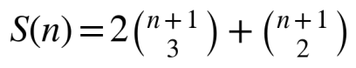 (4)
For n = 5 this yields 2·20 + 15 = 55, in agreement with Fig. 2. Expanding the binomial coefficients gives again n(n+1)(2n+1)/6.

2.7.3 Finite Differences and Geometry
Because the differences S(n) − S(n−1) = n² form a quadratic sequence, S(n) must be a cubic polynomial. Its four coefficients are found by solving the linear system obtained from S(0) = 0, S(1) = 1, S(2) = 5, S(3) = 14, which again yields the same formula. Geometrically, three copies of a square pyramid of layers 1², 2², …, n² can be arranged into a rectangular box of dimensions n × (n+1) × (2n+1)/2, which is the visual reading of the formula.

2.8 Induction and Recursion
Induction and recursion are two faces of the same idea. A recursive definition specifies a base case and a rule that builds each new value from earlier ones; an inductive proof establishes a base case and a rule that transfers truth from one value to the next. Consequently, the correctness of a recursive function is naturally proved by induction on the size of its argument, and the running time of a recursive function is naturally described by a recurrence relation that is solved by induction [3], [6].
For the function that computes S(n) recursively, the base case S(0) = 0 corresponds to the basis step; the call S(n−1) inside S(n) corresponds to invoking the inductive hypothesis; and the addition of n² corresponds to the algebra of the inductive step. The recursive C++ method in this project is therefore a direct “executable” version of the proof, as suggested in the problem statement.

2.9 Applications

2.9.1 Analysis of Algorithms
Nested loops whose inner bound grows with the outer index lead directly to power sums. For instance, the fragment
for (int i = 1; i <= n; i++)
for (int j = 1; j <= i * i; j++)
count++;

executes the innermost statement 1² + 2² + … + n² = S(n) times, which is Θ(n³). Such summations are routine in the analysis of sorting, matrix and graph algorithms [3], [6].

2.9.2 Numerical Integration
The area under y = x² on [0, 1] can be found as the limit of Riemann sums. Dividing the interval into n strips and using right endpoints gives (1/n)·Σ(k/n)² = S(n)/n³. Since S(n)/n³ = 1/3 + 1/(2n) + 1/(6n²), we obtain
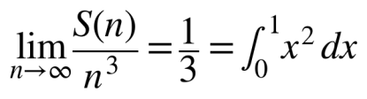 (5)
This is exactly the calculation performed by Archimedes and by every first-year calculus student, and it shows why the leading term n³/3 in the formula is important.

2.9.3 Statistics and Probability
For a fair die, or more generally a discrete uniform variable X on {1, …, n}, the mean is (n+1)/2 and E[X²] = S(n)/n = (n+1)(2n+1)/6. The variance therefore is
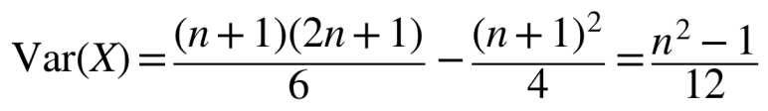 (6)
For a six-sided die (n = 6) this gives 35/12 ≈ 2.92.

2.9.4 Number Theory and Figurate Numbers
The numbers S(n) are the square pyramidal numbers and answer the “cannonball problem” of stacking spheres. A well-known question asks when S(n) is itself a perfect square; apart from the trivial case n = 1 the only solution is n = 24, since S(24) = 4900 = 70² (proved by G. N. Watson in 1918) [10].

2.9.5 Physics and Engineering
Quantities of the type Σ mᵢ rᵢ² appear as the moment of inertia of a system of point masses about an axis. For equal masses m placed at integer distances 1, 2, …, n the moment of inertia is m·S(n). Sums of squares also underlie the mean-square and root-mean-square values used for signals, and the residual sum of squares of least-squares regression.

2.9.6 Program Verification and Teaching
The correctness of a loop is proved with a loop invariant, which is verified by induction on the number of iterations: it holds before the loop (basis) and is preserved by each iteration (inductive step) [3]. The iterative sum-of-squares loop of Section 3.4 is a standard example. The sum of squares is also a favourite first example in discrete mathematics courses because it exposes every element of a proof by induction with minimal algebra [1], [8].

Chapter 3 System Design

3.1 Overall Design
The software component of the project is a small C++ console program. It reads a value of n, evaluates S(n) with three independent methods, prints the three results and reports whether they agree. The design is deliberately simple so that attention stays on the mathematics: each method is one function with a single argument, and the main function only orchestrates input, calls and comparison. Fig. 3 shows the structure.
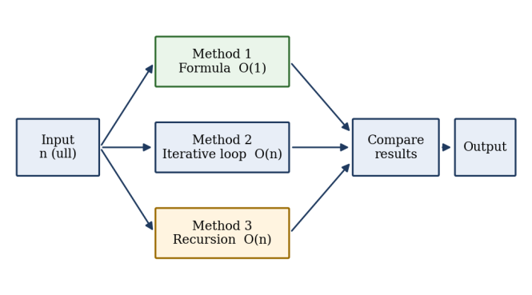
Fig. 3. Block diagram of the sum-of-squares program.

3.2 Theorem and Proof by Induction
Theorem. For every positive integer n,
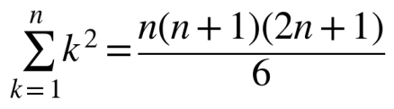 (7)
Proof. Let P(n) denote the statement in Equation (7). The proof proceeds by mathematical induction on n.
Basis step (n = 1). The left-hand side is 1² = 1. The right-hand side is 1·2·3/6 = 1. The two sides are equal, so P(1) is true.
Inductive hypothesis. Assume that P(k) is true for some integer k ≥ 1; that is,
1² + 2² + … + k² = k(k+1)(2k+1)/6.
Inductive step. We must show that P(k+1) holds, i.e. that 1² + 2² + … + (k+1)² = (k+1)(k+2)(2k+3)/6. Adding (k+1)² to both sides of the hypothesis gives
1² + … + k² + (k+1)² = k(k+1)(2k+1)/6 + (k+1)²
= (k+1) [ k(2k+1) + 6(k+1) ] / 6
= (k+1)(2k² + 7k + 6) / 6
= (k+1)(k+2)(2k+3) / 6.
The last step uses the factorisation 2k² + 7k + 6 = (k+2)(2k+3). The final expression is exactly the right-hand side of P(k+1), since (k+1)+1 = k+2 and 2(k+1)+1 = 2k+3. Hence P(k) → P(k+1) for every k ≥ 1.
Conclusion. By the basis step and the inductive step, and by the principle of mathematical induction, P(n) is true for all positive integers n. ∎

3.3 Algorithm 1: Formula Method
The formula method evaluates Equation (7) directly. It performs three multiplications, two additions and one division regardless of n, so it runs in constant time and constant space. The multiplication is carried out before the division; because the product of three consecutive-type factors is always divisible by 6, the integer division is exact.
Algorithm FORMULA(n)
Input : natural number n
Output: S(n) = 1^2 + 2^2 + ... + n^2
1. return n * (n + 1) * (2 * n + 1) / 6

3.4 Algorithm 2: Iterative Method
The iterative method uses a loop that adds the squares one at a time. Correctness is shown with a loop invariant: at the start of iteration i, the variable s equals 1² + … + (i−1)². It holds initially (i = 1, s = 0), it is preserved because the body adds i² and increments i, and at termination (i = n+1) it states that s = S(n). The loop performs n multiplications and n additions, giving O(n) time and O(1) extra space.
Algorithm ITERATIVE(n)
1. s <- 0
2. for i <- 1 to n do
3. s <- s + i * i
4. return s

3.5 Algorithm 3: Recursive Method
The recursive method implements Equation (2) literally. The base case returns 0 for n = 0; the recursive case calls itself with n−1 and adds n². Its correctness is proved by induction on n in exactly the same style as the theorem: if the function returns S(0) = 0 for the base case, and returns S(k−1) + k² = S(k) whenever the recursive call returns S(k−1), then it returns S(n) for all n. The inductive proof and the program are the same argument written in two notations.
Algorithm RECURSIVE(n)
1. if n = 0 then return 0 // base case
2. return RECURSIVE(n - 1) + n * n // inductive step
The execution unfolds in two phases (Fig. 4): a winding phase in which the calls descend from S(n) to S(0), and an unwinding phase in which the partial results 0, 1, 5, 14, … are returned and added. Each pending call occupies a stack frame, so the space complexity is O(n) and the recursion depth equals n. The recurrence for the running time is T(n) = T(n−1) + c with T(0) = c₀, whose solution T(n) = c·n + c₀ is again O(n) (provable by induction).
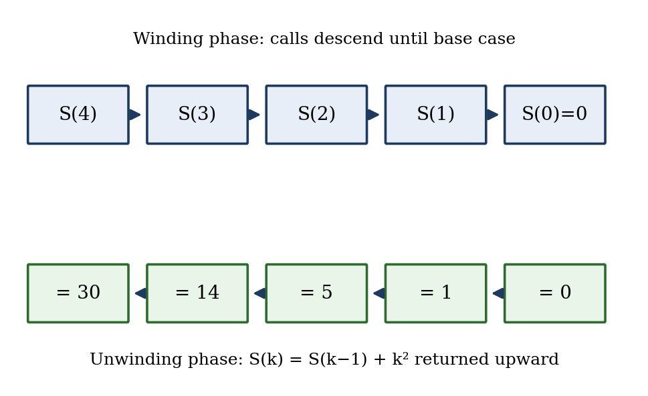
Fig. 4. Winding and unwinding phases of the recursive method for n = 4 (S(4) = 30).

3.6 Complexity Comparison
TABLE II
COMPARISON OF THE THREE METHODS
Method | Time | Extra space | Main advantage | Main limitation
Formula | O(1) | O(1) | Fastest; no loop | Needs the formula (proved by induction)
Iterative | O(n) | O(1) | Simple; safe for large n | Linear time
Recursive | O(n) | O(n) | Mirrors the induction proof | Stack overflow for very large n

3.7 Data Type and Overflow Analysis
All three functions use the 64-bit unsigned type unsigned long long, whose largest value is 2⁶⁴ − 1 ≈ 1.84 × 10¹⁹. The result S(n) ≈ n³/3 fits in this range for n up to about 3.8 million. The formula method is more restrictive because the intermediate product n(n+1)(2n+1) ≈ 2n³ is computed before division, and this exceeds 2⁶⁴ once n is about 2.1 million (2n³ < 2⁶⁴ requires n < 2²¹). For inputs beyond this the intermediate product can be avoided by dividing early (for example, dividing whichever factor is even by 2 and whichever is a multiple of 3 by 3 before multiplying) or by using a 128-bit or arbitrary-precision type.
The recursive method has an additional limit that is not arithmetic: each call consumes stack memory, and a typical default stack of 1–8 MB permits only some hundreds of thousands of frames. The benchmark of Chapter 5 used n up to 100 000 without difficulty; much larger values may crash the program.

3.8 Test Plan
The test plan combines boundary values, small hand-checkable values and large values. The expected results in Table III were obtained from Equation (7) and, for small values, by direct addition. In addition, an exhaustive test compared the three methods for every integer n from 0 to 2000.
TABLE III
TEST CASES AND EXPECTED RESULTS
Test | n | Expected S(n) | Purpose
T1 | 0 | 0 | Empty sum / base case
T2 | 1 | 1 | Basis step of the proof
T3 | 2 | 5 | Smallest non-trivial case
T4 | 5 | 55 | Hand-checkable
T5 | 10 | 385 | Hand-checkable
T6 | 100 | 338350 | Medium value
T7 | 1000 | 333833500 | Large value
T8 | 10000 | 333383335000 | Very large value

Chapter 4 Implementation Details

4.1 Development Environment
TABLE IV
DEVELOPMENT AND TEST ENVIRONMENT
Item | Details
Programming language | C++ (ISO C++ standard [9]; default dialect of the compiler)
Compiler | GNU g++ 13.3.0
Operating system | Ubuntu Linux (x86-64)
Optimisation level | -O0 (no optimisation) so that loops and calls are not removed
Integer type | unsigned long long (64-bit)
Version control | Git / GitHub (see Annexure 1)

4.2 Main Program
Listing 1 gives the complete program. It contains the three functions of Chapter 3 and a main function that reads n, prints the three results and confirms whether they agree.
Listing 1. sumsq.cpp — three methods for the sum of squares
#include <iostream>
using namespace std;
typedef unsigned long long ull;

// Method 1: closed-form formula n(n+1)(2n+1)/6
ull sumFormula(ull n) {
return n * (n + 1) * (2 * n + 1) / 6;
}

// Method 2: iterative summation
ull sumIterative(ull n) {
ull s = 0;
for (ull i = 1; i <= n; i++)
s += i * i;
return s;
}

// Method 3: recursive definition (mirrors the inductive step)
// S(0) = 0 ; S(k) = S(k-1) + k^2
ull sumRecursive(ull n) {
if (n == 0) return 0; // base case
return sumRecursive(n - 1) + n * n; // inductive step
}

int main() {
ull n;
cout << "Enter n: ";
cin >> n;
cout << "Formula : " << sumFormula(n) << endl;
cout << "Iterative : " << sumIterative(n) << endl;
cout << "Recursive : " << sumRecursive(n) << endl;
cout << (sumFormula(n) == sumIterative(n) &&
sumIterative(n) == sumRecursive(n)
? "All three methods agree." : "Mismatch detected!") << endl;
return 0;
}

4.3 Explanation of the Code
- typedef unsigned long long ull. A short alias for the 64-bit unsigned type used throughout, which avoids negative values and gives the largest standard integer range.
- sumFormula. Evaluates n(n+1)(2n+1)/6 in one expression. Multiplication precedes division, so the result is exact integer arithmetic, provided that the product does not overflow (Section 3.7).
- sumIterative. Initialises an accumulator to zero and adds i·i for i = 1, …, n. The loop invariant of Section 3.4 guarantees correctness.
- sumRecursive. Returns 0 when n is 0 (the basis) and otherwise returns the result for n−1 plus n·n (the inductive step). It is a line-by-line translation of Equation (2).
- main. Reads n from standard input, prints the three results and uses the comparison of the last statement as an automatic self-check. Agreement of three independently structured computations is strong evidence that both the code and the formula are correct.

4.4 Benchmark Program
To compare running times, a second program calls each function 200 times for a given n and reports the mean time per call in microseconds, using the high-resolution clock of the C++ chrono library. A volatile variable accumulates the results so that the compiler cannot discard the calls. Listing 2 shows the timing routine and its use.
Listing 2. bench.cpp — timing of the three methods (excerpt)
template<class Fn>
double timeIt(Fn f, ull n, ull &out) {
int reps = 200;
auto a = chrono::high_resolution_clock::now();
volatile ull sink = 0;
for (int r = 0; r < reps; r++) sink += f(n);
auto b = chrono::high_resolution_clock::now();
out = sink / reps;
return chrono::duration<double, micro>(b - a).count() / reps;
}

ull ns[] = {10, 100, 1000, 10000, 100000};
for (ull n : ns) {
double tf = timeIt(sumFormula, n, o1);
double ti = timeIt(sumIterative, n, o2);
double tr = timeIt(sumRecursive, n, o3);
// print n, tf, ti, tr and the value S(n)
}

4.5 Implementation Notes
- The program can be compiled with the command g++ -O0 -o sumsq sumsq.cpp and run as ./sumsq. Optimisation was disabled for the benchmark because an optimising compiler may replace the loop by a closed form or convert the recursion into a loop, which would hide the differences being studied.
- Input is assumed to be a non-negative integer. A production version should validate the input, reject negative numbers (which wrap around for an unsigned type) and warn when n exceeds the safe range of Section 3.7.
- An exhaustive test (a loop over n = 0, …, 2000 comparing all three methods) reported zero mismatches, and the eight cases of Table III were also run individually.
- The source code was uploaded to a GitHub repository by the group (screenshot in Annexure 1), and each member contributed to coding, testing or documentation.

Chapter 5 Result Screenshots and Analysis

5.1 Program Output
Figures 5 to 9 show the console output of the program for n = 5, 10, 100, 1000 and 10000. In every case the three methods print identical values and the program confirms their agreement.
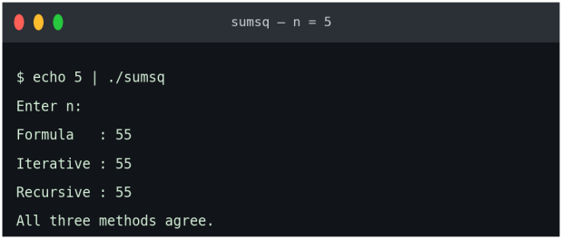  Fig. 5. Output for n = 5: S(5) = 55. | 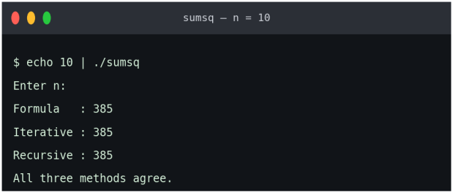  Fig. 6. Output for n = 10: S(10) = 385.
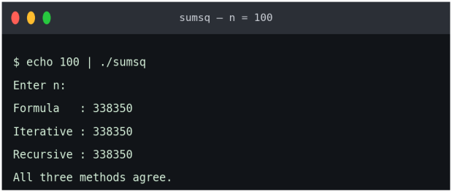  Fig. 7. Output for n = 100: S(100) = 338350. | 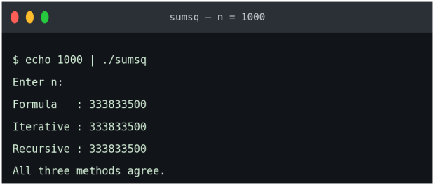  Fig. 8. Output for n = 1000: S(1000) = 333833500.
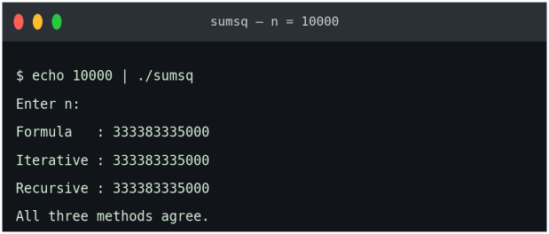
Fig. 9. Output for n = 10000: S(10000) = 333383335000.

Table V lists the first ten values of S(n), together with the squares that are added at each step; each entry equals the previous entry plus n², as Equation (2) requires.
TABLE V
VALUES OF N², S(N) AND THE FORMULA FOR N = 1 TO 10
n | n² | S(n) by iteration | n(n+1)(2n+1)/6 | Match
1 | 1 | 1 | 1 | ✓
2 | 4 | 5 | 5 | ✓
3 | 9 | 14 | 14 | ✓
4 | 16 | 30 | 30 | ✓
5 | 25 | 55 | 55 | ✓
6 | 36 | 91 | 91 | ✓
7 | 49 | 140 | 140 | ✓
8 | 64 | 204 | 204 | ✓
9 | 81 | 285 | 285 | ✓
10 | 100 | 385 | 385 | ✓

5.2 Growth of the Sum
Fig. 10 plots S(n) for n = 1 to 30 together with its leading term n³/3. The two curves are close for large n and the relative difference shrinks as n grows, in agreement with the limit S(n)/n³ → 1/3 of Section 2.9.2. The sequence is convex, reflecting the increasing size of the terms n².
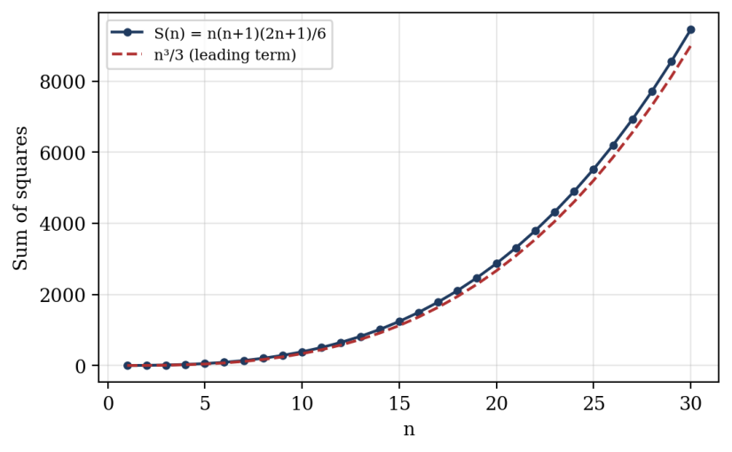
Fig. 10. Growth of S(n) compared with n³/3 for n = 1 to 30.

5.3 Performance Comparison
Table VI and Fig. 11 show the mean time per call of the three methods. The formula method takes about three nanoseconds regardless of n. The iterative and recursive methods grow linearly: multiplying n by ten multiplies the time by roughly ten, which is visible as parallel lines of slope one on the logarithmic plot. The recursive method is about three to four times slower than the loop at large n because of the overhead of function calls and stack-frame creation.
TABLE VI
MEAN TIME PER CALL (MICROSECONDS) ON THE TEST MACHINE
n | Formula | Iterative | Recursive | Recursive / iterative
10 | 0.0033 | 0.0192 | 0.0335 | 1.7
100 | 0.0031 | 0.2503 | 0.9328 | 3.7
1 000 | 0.0030 | 2.5612 | 8.3869 | 3.3
10 000 | 0.0031 | 27.3292 | 98.4027 | 3.6
100 000 | 0.0030 | 298.3614 | 1007.5045 | 3.4

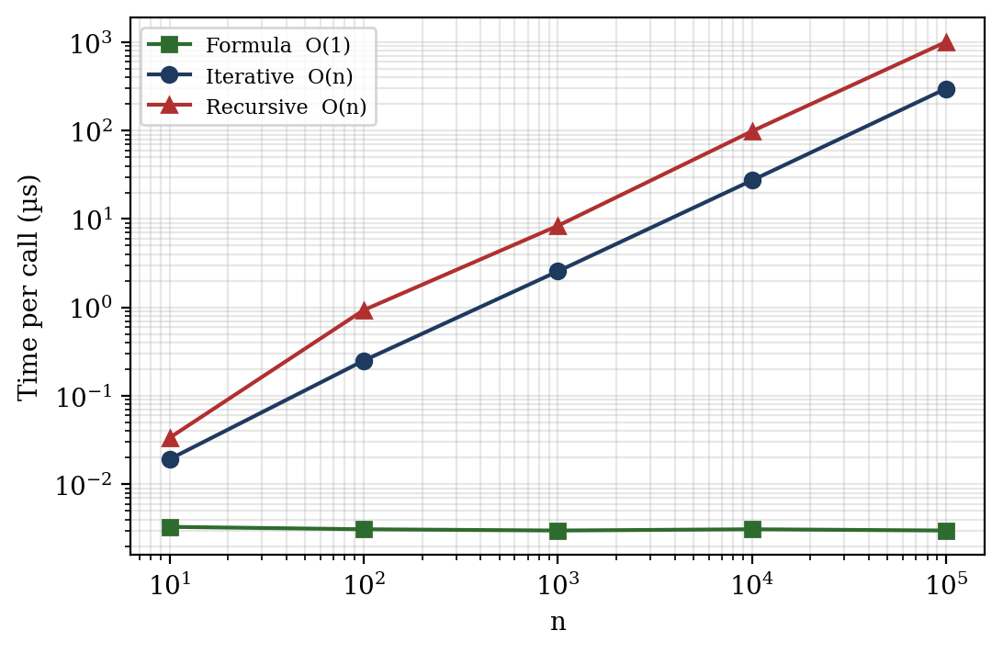
Fig. 11. Running time of the three methods versus n (logarithmic axes).
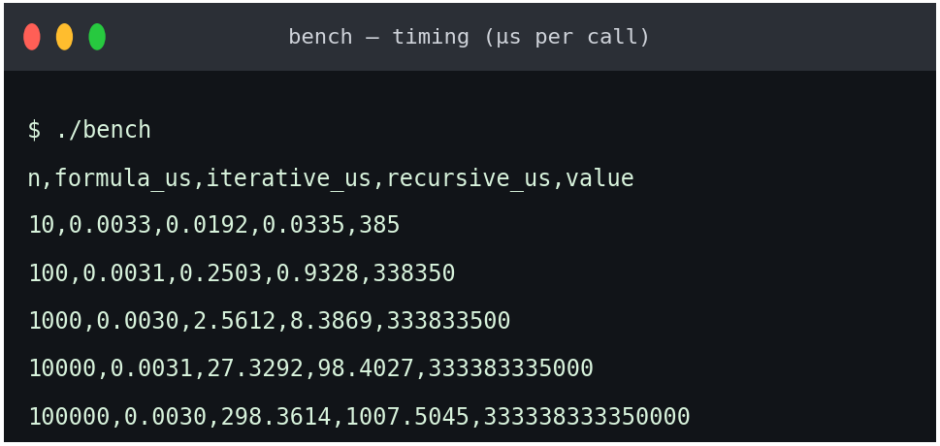
Fig. 12. Output of the benchmark program (time in microseconds per call).

5.4 Analysis of Results
- Correctness. The three methods gave identical results in all eight test cases of Table III and for every n from 0 to 2000. This agrees with the theorem proved by induction in Section 3.2.
- Efficiency. The formula method is constant-time and is the clear choice for computation. The loop is linear with a small constant. The recursive method is also linear but slower and uses linear stack space.
- Scalability. The formula method is limited by overflow of the intermediate product at about n = 2.1 × 10⁶; the iterative method is limited only by the size of the result (about 3.8 × 10⁶ for 64-bit integers); the recursive method is additionally limited by stack depth.
- Educational value. Although the recursive method is not the fastest, it displays the structure of an inductive proof: a base case, a step that uses the “hypothesis” (the recursive call), and a conclusion for all n.
Absolute times will differ on other computers, compilers and optimisation levels, but the growth trends are a property of the algorithms and will be the same.

5.5 Problem Solutions
The following problems illustrate how the technique applies to related sums.
Problem 1. Evaluate 1² + 2² + … + 20². Solution: S(20) = 20·21·41/6 = 17220/6 = 2870.
Problem 2. Find the smallest n for which S(n) > 1000. Solution: S(13) = 13·14·27/6 = 819 and S(14) = 14·15·29/6 = 1015. Because S is increasing, the smallest such n is 14.
Problem 3. Prove by induction that 1² + 3² + … + (2n−1)² = n(2n−1)(2n+1)/3. Solution: Basis: for n = 1 both sides equal 1. Step: assume the formula for k. Adding (2k+1)² gives k(2k−1)(2k+1)/3 + (2k+1)² = (2k+1)[k(2k−1) + 3(2k+1)]/3 = (2k+1)(2k²+5k+3)/3 = (2k+1)(2k+3)(k+1)/3, which is the formula for k+1 because 2(k+1)−1 = 2k+1 and 2(k+1)+1 = 2k+3. For n = 3: 1 + 9 + 25 = 35 = 3·5·7/3. ∎
Problem 4. Find 2² + 4² + … + 20². Solution: The sum equals 4S(10) = 4·385 = 1540. In general, the sum of the first n even squares is 4S(n) = 2n(n+1)(2n+1)/3.
Problem 5. Prove that Σk(k+1) = n(n+1)(n+2)/3. Solution: Basis: 1·2 = 2 = 1·2·3/3. Step: if the formula holds for n, then adding (n+1)(n+2) gives n(n+1)(n+2)/3 + (n+1)(n+2) = (n+1)(n+2)(n+3)/3, which is the formula for n+1. ∎
Problem 6. Show that S(n) > n³/3 for all n ≥ 1. Solution: S(n) = (2n³ + 3n² + n)/6 = n³/3 + n²/2 + n/6 > n³/3, since n²/2 + n/6 > 0.
Problem 7. Verify that S(24) is a perfect square. Solution: S(24) = 24·25·49/6 = 4·25·49 = 4900 = 70².
Problem 8. Find the variance of the score of a fair six-sided die. Solution: With n = 6, Var = (n²−1)/12 = 35/12 ≈ 2.92 (Section 2.9.3).

5.6 A Cautionary Example
The basis step is not a formality. Consider the false claim Q(n): S(n) = n(n+1)(2n+1)/6 + 1. Suppose Q(k) holds. Then S(k+1) = S(k) + (k+1)² = k(k+1)(2k+1)/6 + 1 + (k+1)² = (k+1)(k+2)(2k+3)/6 + 1, so Q(k) → Q(k+1) is a valid inductive step. Nevertheless Q(1) is false, since S(1) = 1 while the right-hand side equals 2. The chain of implications is intact but nothing starts it, so Q(n) is false for every n. Both parts of a proof by induction are therefore indispensable, and the program’s base case “if (n == 0) return 0” plays the same role in code.

Chapter 6 Conclusion

6.1 Conclusion
This project proved, by mathematical induction, that the sum of the squares of the first n natural numbers equals n(n+1)(2n+1)/6. The proof was completed with a basis step for n = 1 and an inductive step that adds (k+1)² to the hypothesis and factorises the result. The same formula was obtained independently by telescoping and by a combinatorial argument, which strengthens confidence in the result.
The formula was then implemented in C++ in three ways. The formula method is constant-time; the iterative method is linear-time with constant space; and the recursive method, which mirrors the inductive proof, is linear in both time and stack space. All three agreed on every tested input (n = 0 to 2000 exhaustively, and selected values up to 100 000), and the benchmarks confirmed the theoretical complexities. Overflow analysis showed the safe ranges of the 64-bit implementations, and the solved problems and applications showed that the technique extends to related sums and to areas such as algorithm analysis, integration and statistics.
The project demonstrates in a concrete way that induction and recursion are two expressions of a single idea, and that a mathematical proof, an algorithm and a program can be viewed as complementary descriptions of the same fact.

6.2 Future Scope
- Extending the study to higher power sums Σk³ and Σk⁴ and to the general Faulhaber–Bernoulli formula, with C++ implementations.
- Using arbitrary-precision or 128-bit arithmetic to remove the overflow limits of Section 3.7.
- Adding input validation and a simple graphical or web interface, and formal verification of the recursive function in a proof assistant.
- Comparing the methods under different compiler optimisation levels and on different processors, including tail-recursive and memoised variants.

References
[1] K. H. Rosen, Discrete Mathematics and Its Applications, 8th ed. New York, NY, USA: McGraw-Hill Education, 2019.
[2] R. L. Graham, D. E. Knuth, and O. Patashnik, Concrete Mathematics: A Foundation for Computer Science, 2nd ed. Reading, MA, USA: Addison-Wesley, 1994.
[3] T. H. Cormen, C. E. Leiserson, R. L. Rivest, and C. Stein, Introduction to Algorithms, 4th ed. Cambridge, MA, USA: MIT Press, 2022.
[4] B. Stroustrup, The C++ Programming Language, 4th ed. Upper Saddle River, NJ, USA: Addison-Wesley, 2013.
[5] D. E. Knuth, The Art of Computer Programming, Vol. 1: Fundamental Algorithms, 3rd ed. Reading, MA, USA: Addison-Wesley, 1997.
[6] R. Johnsonbaugh, Discrete Mathematics, 8th ed. Boston, MA, USA: Pearson, 2018.
[7] S. S. Epp, Discrete Mathematics with Applications, 5th ed. Boston, MA, USA: Cengage Learning, 2019.
[8] G. Pólya, How to Solve It: A New Aspect of Mathematical Method, 2nd ed. Garden City, NY, USA: Doubleday, 1957.
[9] Programming Languages—C++, ISO/IEC Standard 14882:2020, International Organization for Standardization, Geneva, Switzerland, 2020.
[10] J. H. Conway and R. K. Guy, The Book of Numbers. New York, NY, USA: Springer-Verlag, 1996.
[11] J. Bernoulli, Ars Conjectandi. Basel, Switzerland: Thurneysen Brothers, 1713.

Annexure 1
GitHub Upload Screenshot


Annexure 2
Presentation Geo-Tag Photo
.


Annexure 3
Certificate of Online Course Related to Discrete Mathematics







